**Id code: 19CM029 Name:** Dhiraj M. Jagtap Sem: 5th

**Practical No. 1:**

**Aim:**

a. Install and configure PHP, web server, MYSQL

b. Write a program to print “Welcome to PHP”

c. Write a simple PHP program using expressions and operators.

**How to install php server:**

XAMPP is one of the widely used cross-platform web servers, which helps developers to create and test their programs on a local webserver. It was developed by the Apache Friends, and its native source code can be revised or modified by the audience. It consists of Apache HTTP Server, MariaDB, and interpreter for the different programming languages like PHP and Perl. It is available in 11 languages and supported by different platforms such as the IA-32 package of Windows & x64 package of macOS and Linux.

**Step1:**

Open the XAMPP website. Go to https://www.apachefriends.org/index.html in your computer's web browser.

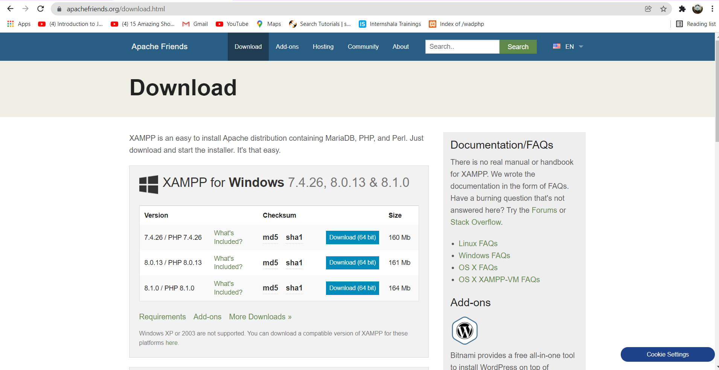

**Step2:**

Click XAMPP for Windows. It's a grey button near the bottom of the page. Depending on your browser, you may first have to select a save location or verify the download. 0

**Step3:**

Double-click the downloaded file. This file should be named something like xampp-win32-7.2.4-0-VC15-installer, and you'll find it in the default downloads location (e.g., the "Downloads" folder or the desktop).

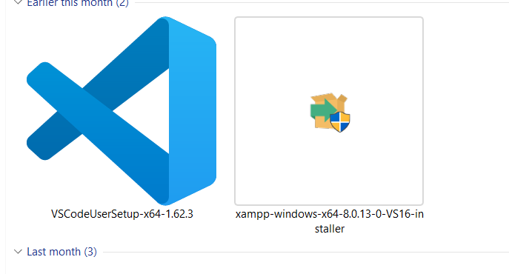



**Step 4**

Click Yes when prompted. This will open the XAMPP setup window. You may have to click OK on a warning if you have User Account Control (UAC) activated on your computer.

**Step 5:**

Click Next. It's at the bottom of the setup window.

**Step 6:**

Select aspects of XAMPP to install. Review the list of XAMPP attributes on the left side of the window; if you see an attribute that you don't want to install as part of XAMPP, uncheck its box. By default, all attributes are included in your XAMPP installation.

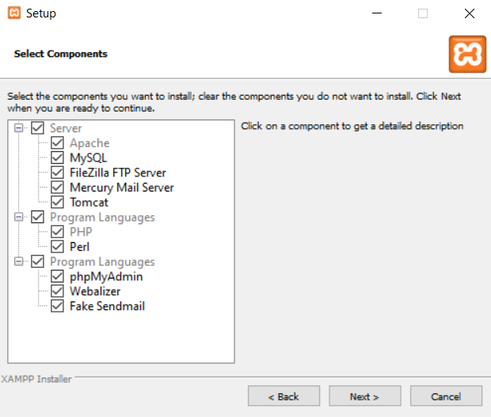

**Step7:** Click Next. It's at the bottom of the window. 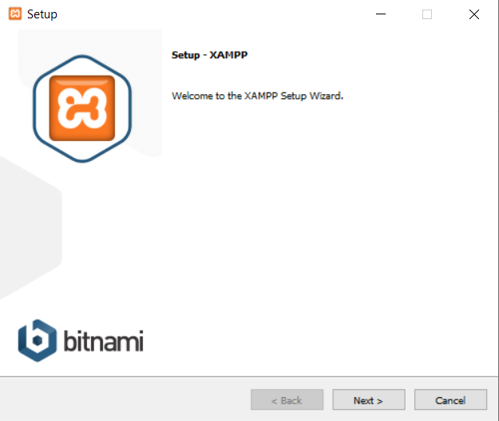



**Step 8:**

Select an installation location. Click the folder-shaped icon to the right of the current installation destination, then click a folder on your computer. If you have the UAC activated on your computer, avoid installing XAMPP in your hard drive's folder (e.g., OS (C:)). You can select a folder (e.g., Desktop) and then click Make New Folder to create a new folder and select it as the installation destination.

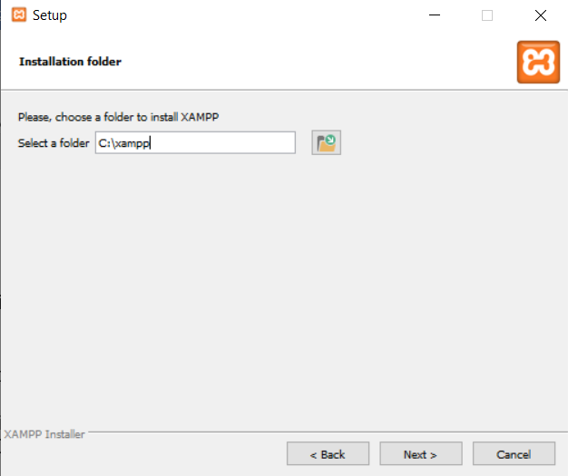

**Step 9:** Click OK. Doing so confirms your selected folder as your XAMPP installation location. **step** **18:**

Click on Start button of (Apache Server, PHP, and MySql). Now Web server is ready to execute PHP and MySql program.

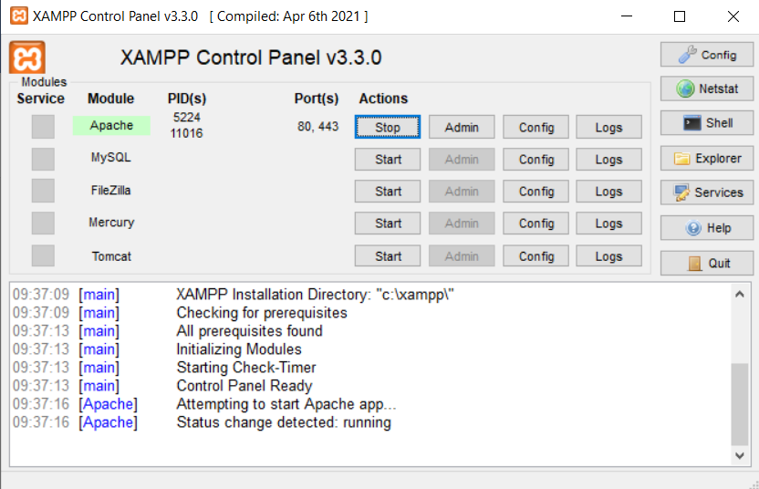



**B: Write a program to print “Welcome to PHP”**

**Program:**

<?php

echo "Welcome to Php";

?>

**Output:**

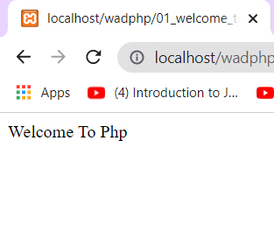

**C. Write a program to demonstrate the operators and expressions in Php**

<?php

$a = 20;

$b = 5;

$c ;

//operators are used to manuplate.

//Addition Operator:

$c = $a + $b;

echo "Addition of two Numbers".$c;

echo "<br>";

//Subtraction Operator:

$c = $a - $b;

echo "Subtraction of two Numbers:". $c;

//multiplication Operator:

$c = $a * $b;

echo "<br>Multiplication of two Numbers:" .$c;

//Division Operator:

$c = $a / $b;

echo "<br>Multiplication of two Numbers:". $c;

//Modd Operator:

$c = $a % $b;

echo "<br>Multiplication of two Numbers:" .$c;

//Exponent Operator:

$c = $a ** $b;

echo "<br>Multiplication of two Numbers:". $c;

// x += y; is x = x + y Addition

echo "addition:".$c += $a;

echo "<br>";

// x -= y x = x – y Subtraction

echo "Subtraction:".$c -= $a;

echo "<br>";

// x *= y x = x * y Multiplication

echo "multiplication:".$c *= $a;

echo "<br>";

// x /= y x = x / y Division

echo "Divison:".$c /= $a;

echo "<br>";

// x %= y x = x % y Modulus

echo "Modd:".$c %= $a;

echo "<br>";

?>

**Output:**

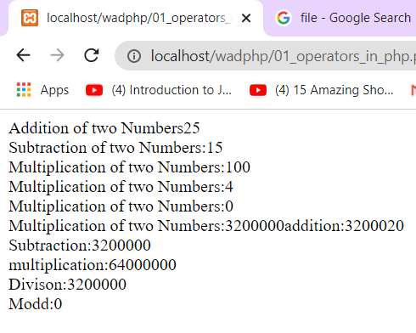

**Conclusion:** Hence we have performed programs of operators, expression successfully.